Landgrove Historical Society
2023 Calendar of Events

Please join us in helping document and preserve the history of our terrific town. Our collections include hundreds of old photographs of people and places, books by Landgrove authors, books relevant to our history, artwork by Landgrove artists, archival documents, and a few worthy historical objects. We also sponsor town-wide events open to all.

We are open on Thursday mornings, 9-noon, at our office in the town hall. Our contact information is landgrovehs@gmail.com

Coming Events

July 2 (Sun) Square dance at the Bloom’s barn. 7-10 PM

July 4 (Tue) Group reading and discussion of the fiery 4th of July Frederick Douglass 1852 address commemorating the signing of the Declaration of Independence.
Co-sponsored with the Landgrove Meeting House. David Eckhardt moderator.
2 PM at the Meeting House.

July 16 (Sun) Annual meeting, 10:30 AM, at the Town Hall.

July 16 (Sun) Summer show: The Photography of Hubert Schriebl 10:30 AM, at the Town Hall

Aug. 7 (Mon) A walk through the ruins of Stone Farm and Cemetery, led by Jonathan Bigelow.
Meet at the Town Hall at 2 PM.

Oct. 18 (Wed) Old Barns of Vermont by Jonathan Bigelow. Co-sponsored with the Landgrove Meeting House. At the Town Hall, 4 PM.

Below is the proposed board for the coming year to be approved at the annual meeting.
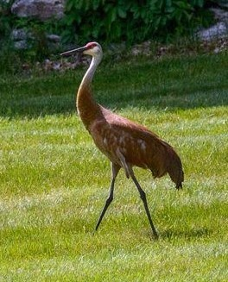
President: Rob Badger
Treasurer: Meg Pennypacker
Secretary: Christine Morfit
Directors: Marion Sweetman
Jonathan Bigelow
May Bigelow
Sally Ogden
David Eckhardt
Kathy Snyder
Susan Goetze
Advisors: Ann Ogden Hausslein
Priscilla Grayson
Hope Pinkerton
We are striving to put together another Landgrove Cookbook, similar to the one Bobby Comfort published in 1963. We sent out a request for recipes in late January, but have received very few contributions. Because it was sent to so many people, we think our original email may have gone into spam or promotions mailbox. So we are repeating our call for recipes here. We will include recipes for: Drinks, Appetizers, Soups, Breads, Eggs & Cheese Dishes, Vegetables, Fish, Poultry, Meat, Game, Sauces, Relishes, Salads, Dressings, Cookies, Pies, Cakes and Desserts. Please send your recipes to: randcbadger@gmail.com or landgrovehs@gmail.com

We are in the process of editing and republishing The Cheese that Changed Many Lives by Sam Ogden. And we have reprinted Fading Memories from a Vermont Hillside by Robert & William Badger. Both are available at our office for purchase.

Books we now have for purchase:

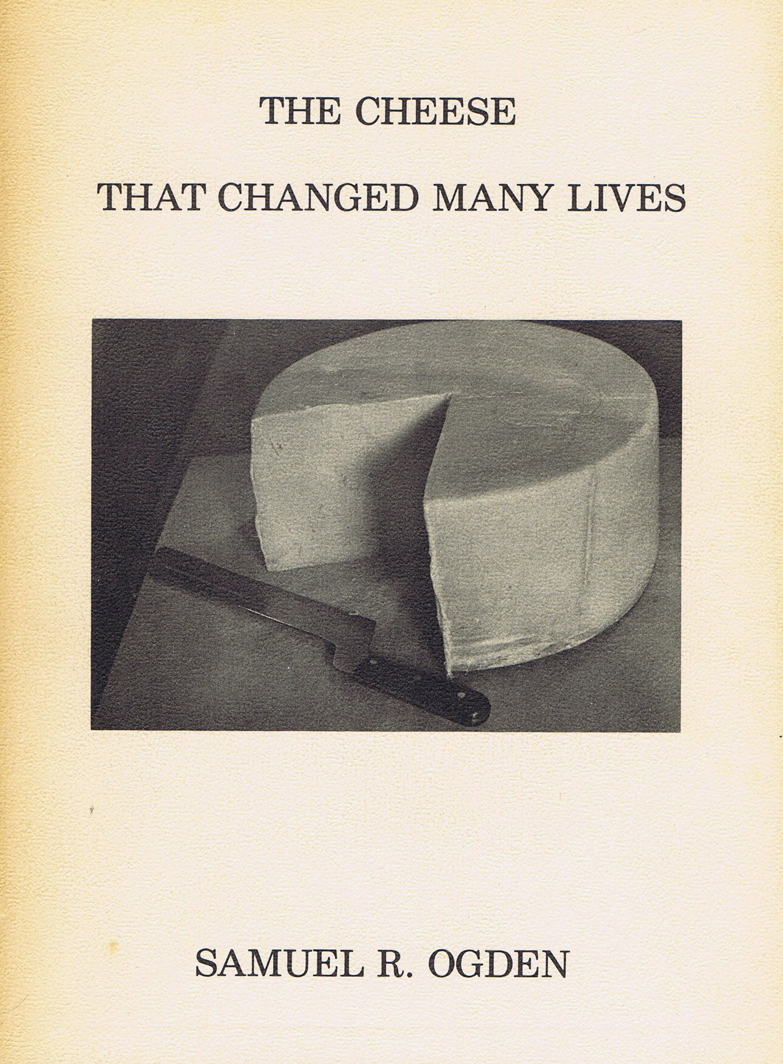
The Cheese that Changed Many Lives by Samuel R. Ogden
Sam Ogden’s narration of his arrival in the essentially deserted Village of
Landgrove. Currently in the process of being edited and reprinted.
Should be available by our annual meeting.
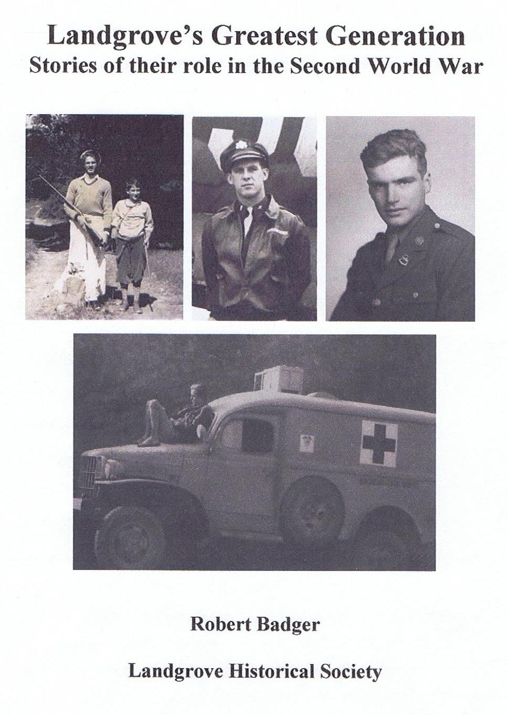
Landgrove’s Greatest Generation by Robert Badger $10
About the many contributions of our citizens to the WW II effort.

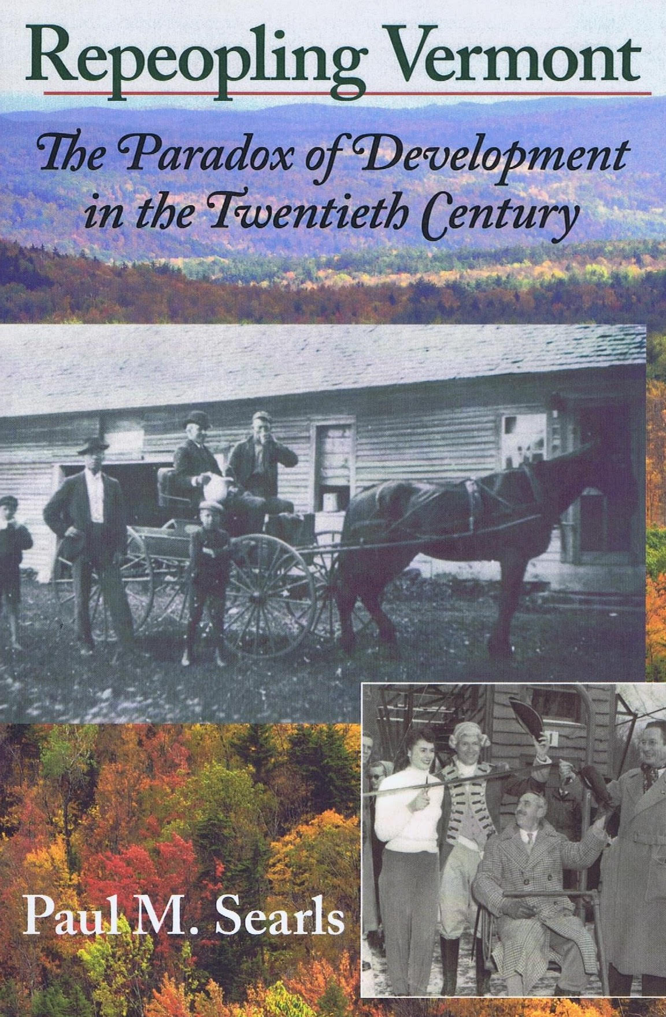
Repeopling Vermont by Paul Searls $23
A wonderful book in two parts, both about Landgrove. The first traces the history
of the Swedes who came here to farm in 1890; the second is about Sam Ogden’s
arrival and his impact on both the town and the state.

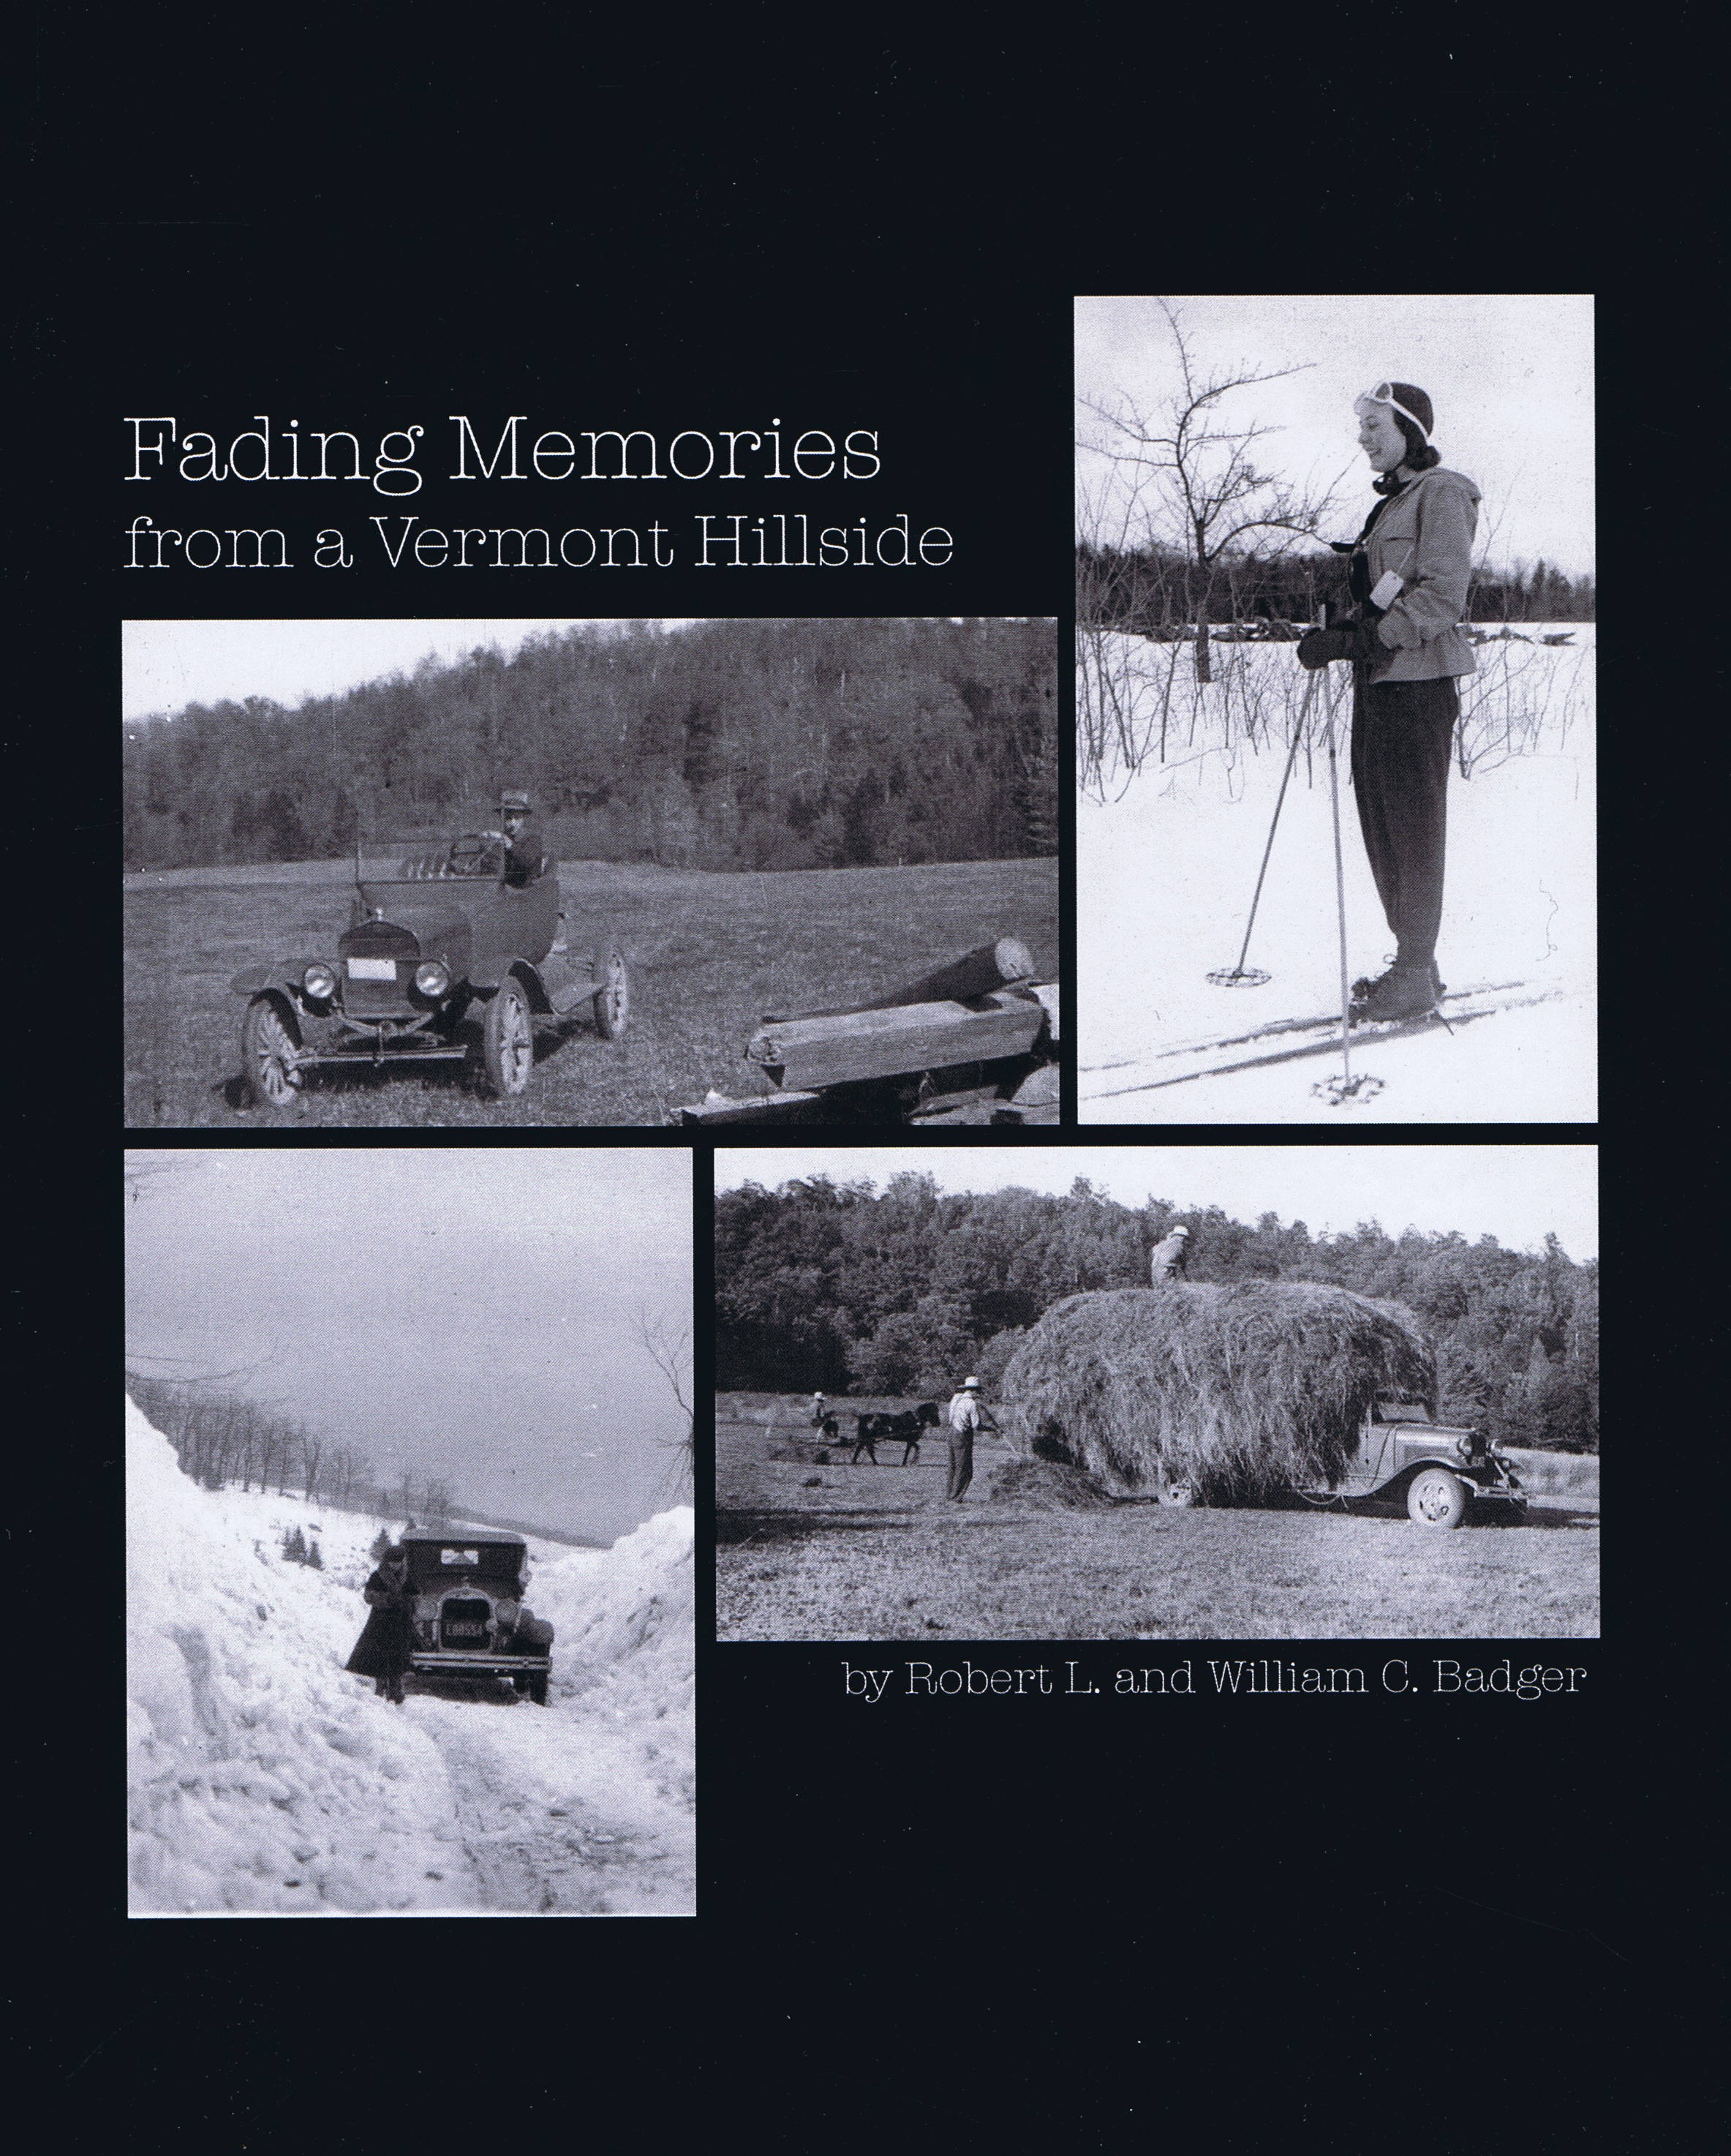
Fading Memories from a Vermont Hillside by Robert & William Badger $15
A story about the Badger Family land on Ridge Road, purchased by their
grandfather in 1929, with many photographs taken by their father in the 1920’s
and 1930’s. Just reprinted.

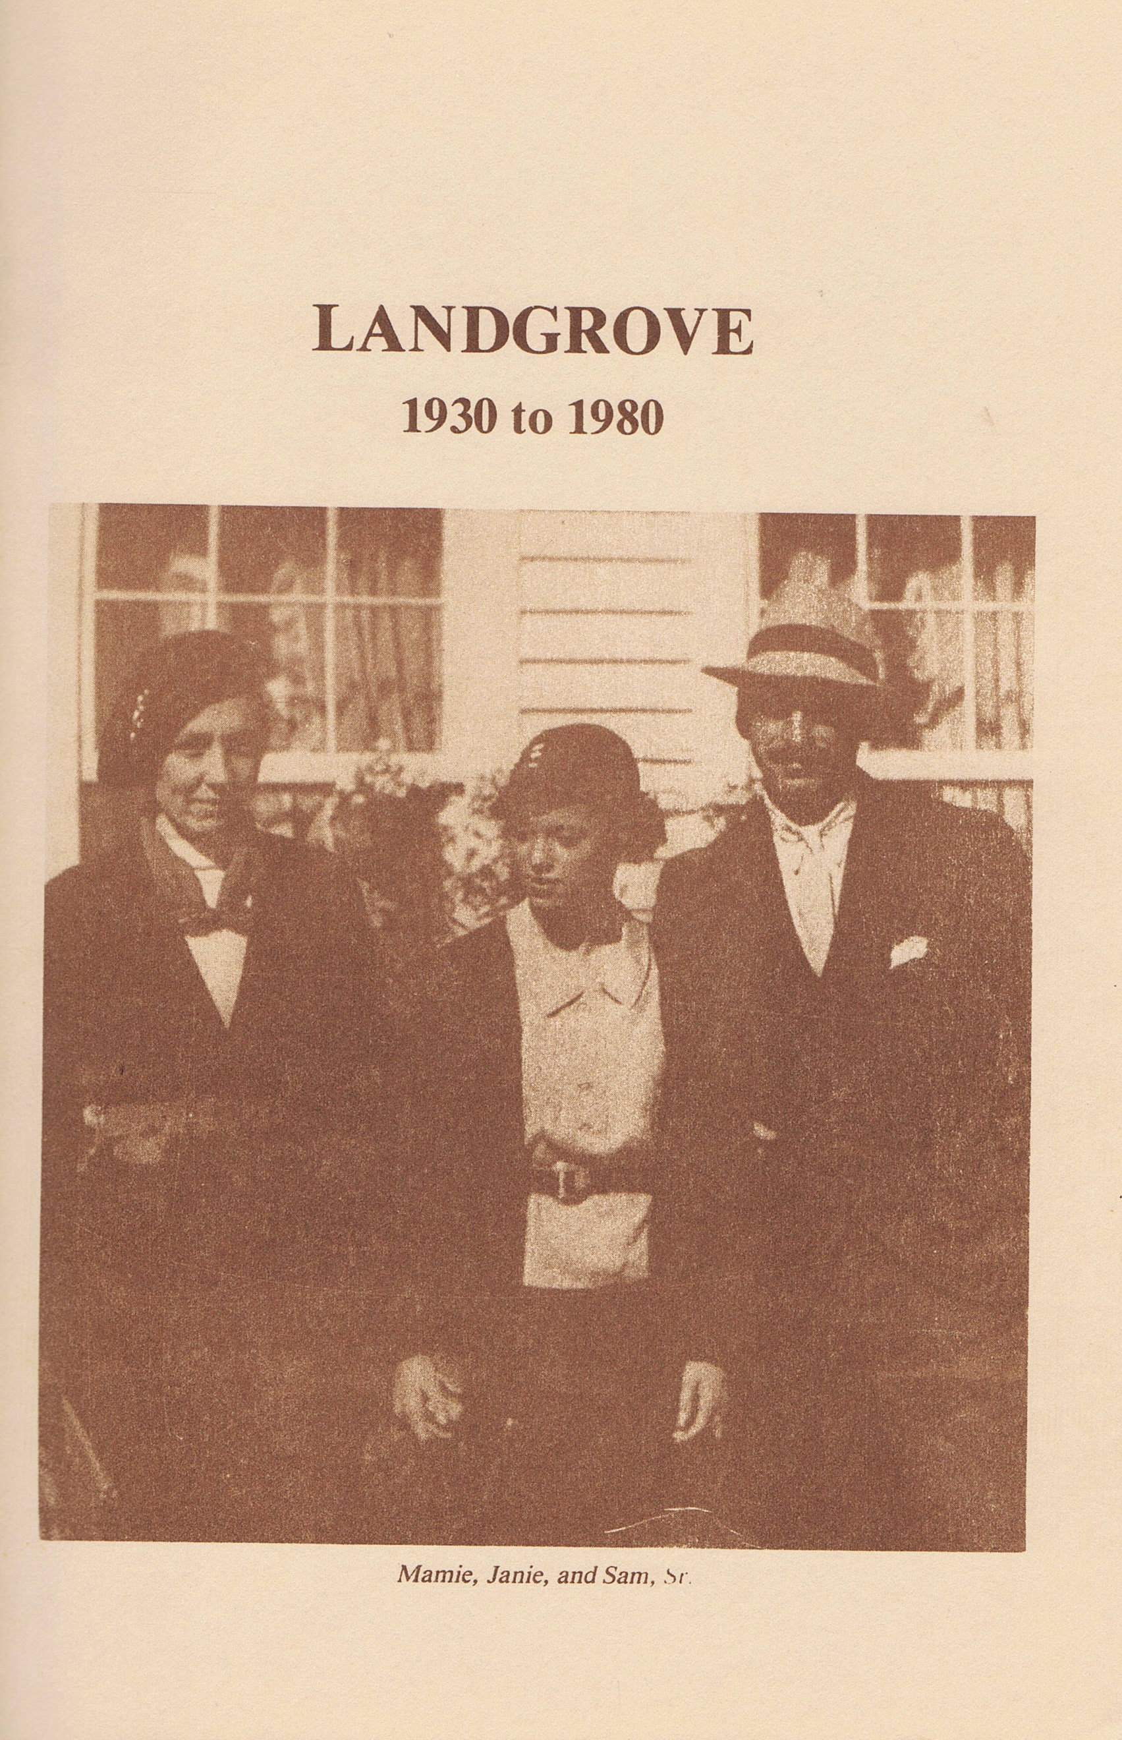
Landgrove 1930 to 1980 by Isabel Gwinn Free
Many fine pictures in this story of life in Landgrove primarily during the 60’s and 70’s.
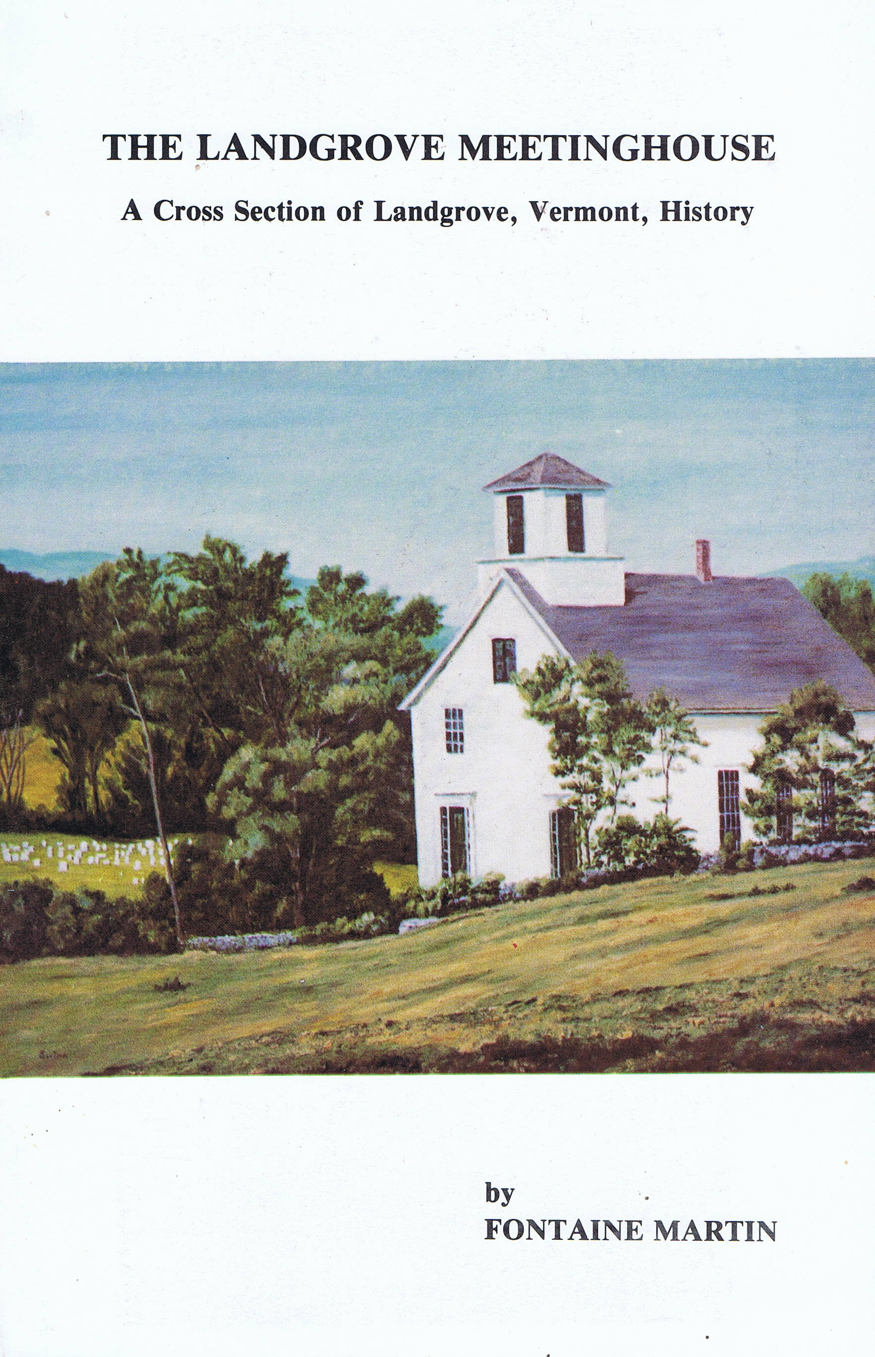
The Landgrove Meeting House by Fontaine Martin $10
The best book available on the history of Landgrove. Only 5 copies remain.

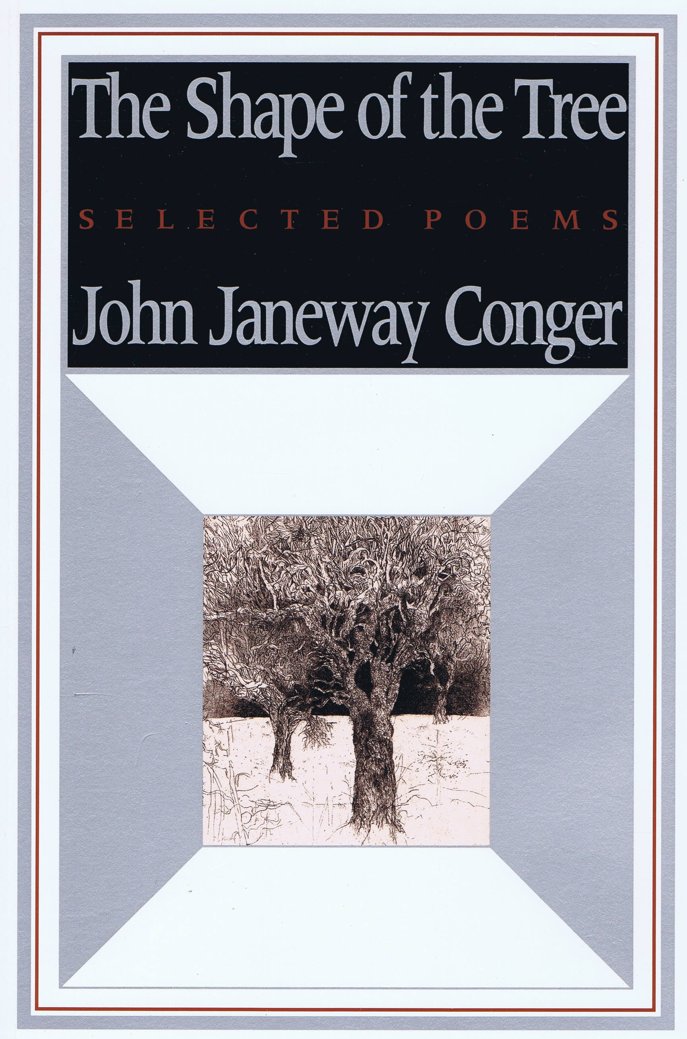
The Shape of the Tree by John Conger $5
Selected poems by former resident John Conger. Only 6 copies remain.

